**Billing System Assignment**

**Step 1:Create new repository “Billing System ” in azure devops**

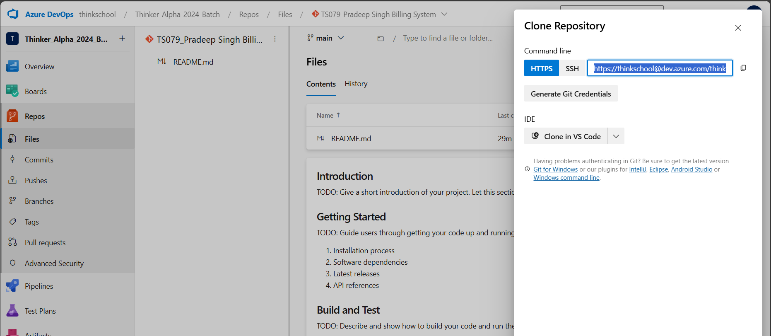

**Step 2: Git init & Status**

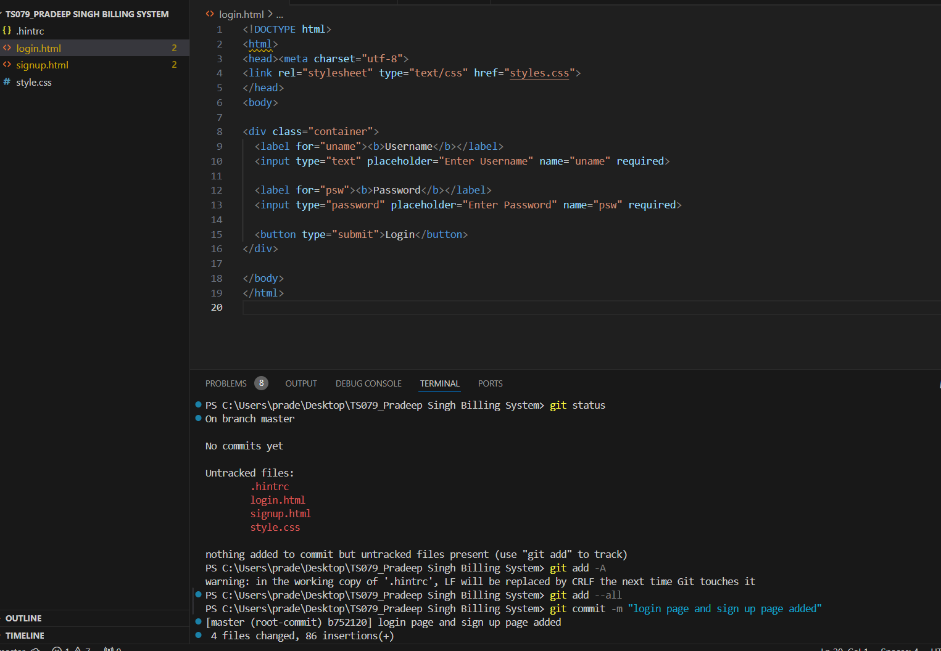



**Step 3: Git add & commit login and sign-up page to local repository**

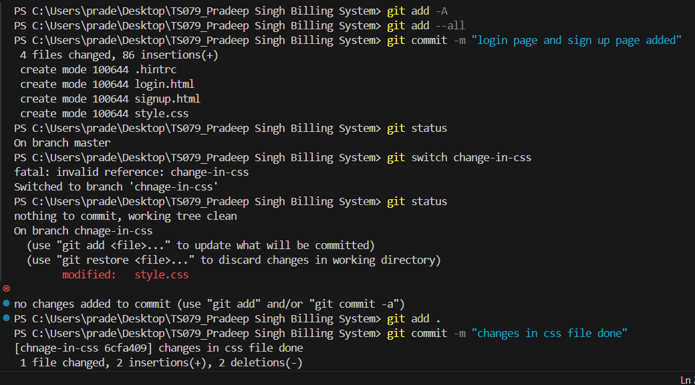



**Step 4:Creating new branch “change-in-css” and modified in style.css file  
and add & commit**





**Step 5:Merging and deleting “change-in-css” to master and deleting it:**

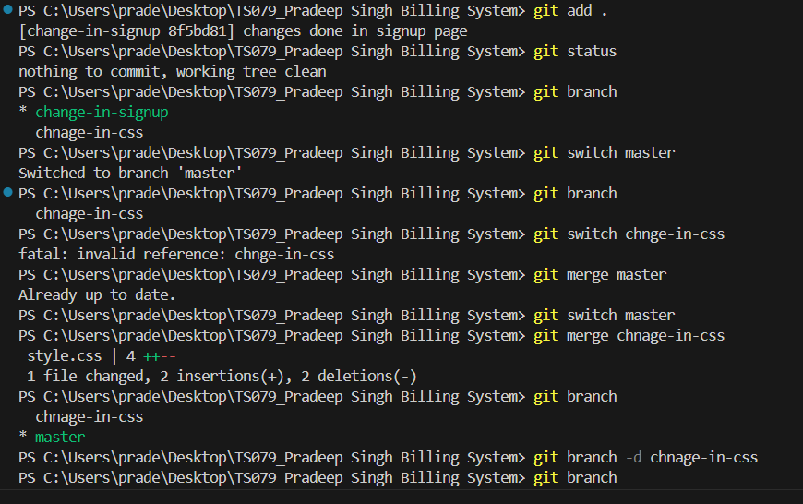



**Step 6:Creating new branch called ”change-in-signup” and make change in signup add & commit**

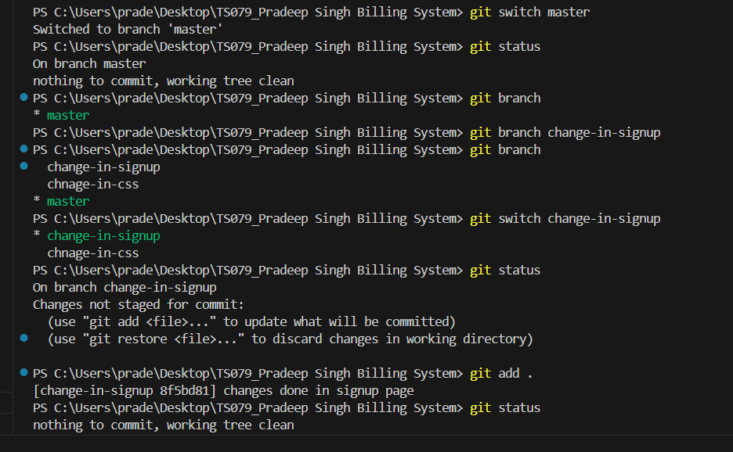



**Step 7: Create a new branch from master called ‘’emergency-fix’’ to add forget password page and also suffle the line from signup page (for creating conflict)**

**Add & commit**

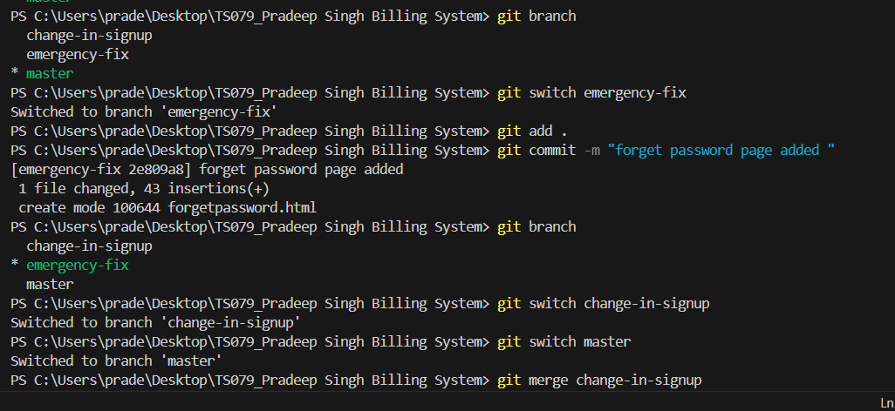



**Step 8:Merge changes-in-signup to master branch**

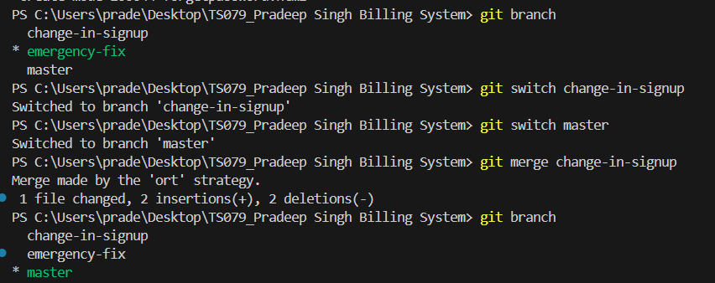



**Step 9:Merge emergency-fix to master due to suffle in line (signup page) there will be conflict**

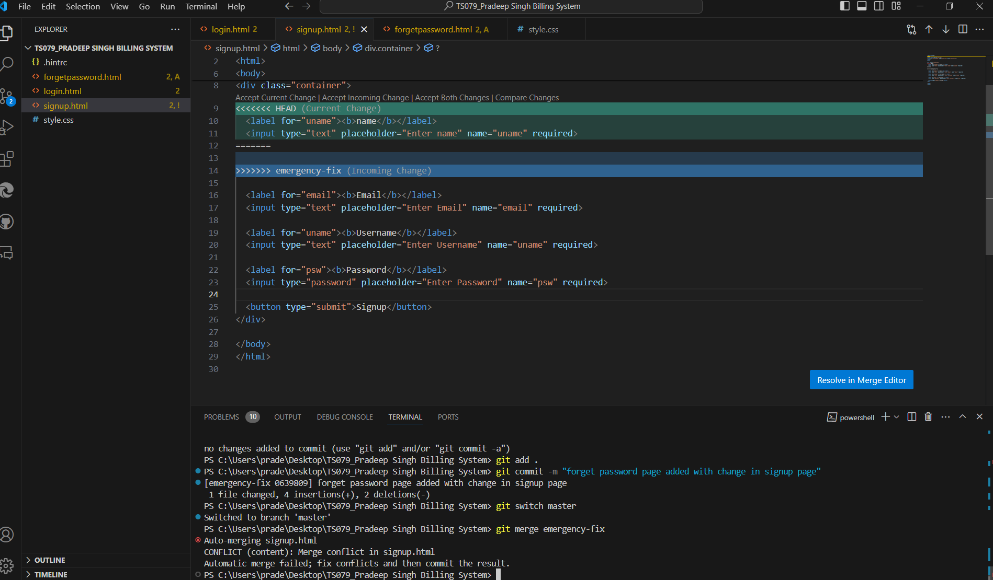



Conflict shown in both the lines



**Step 10: Resolving the conflict and completing merge and commit :**

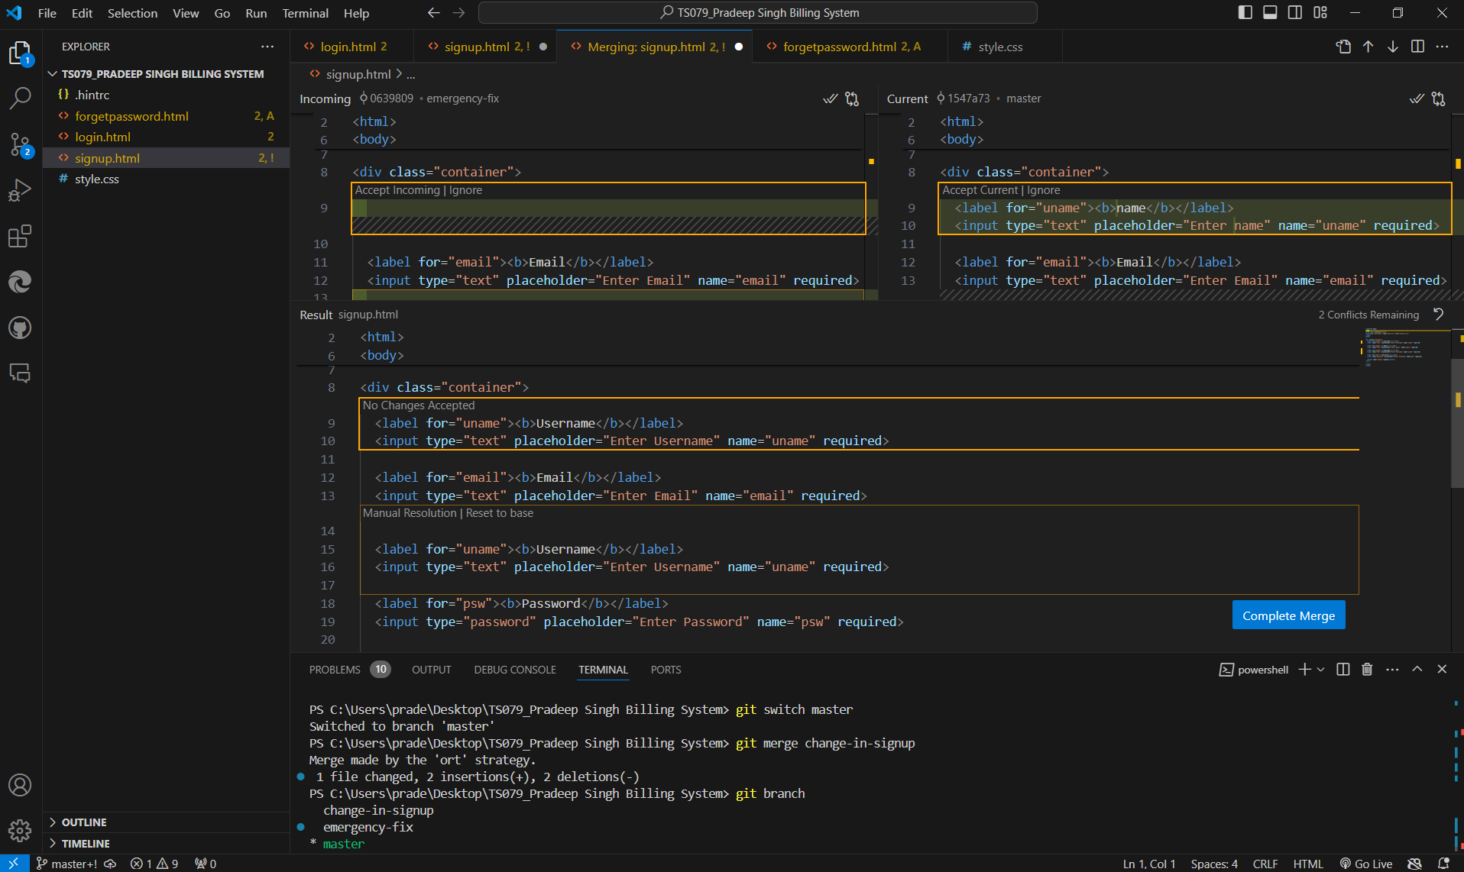

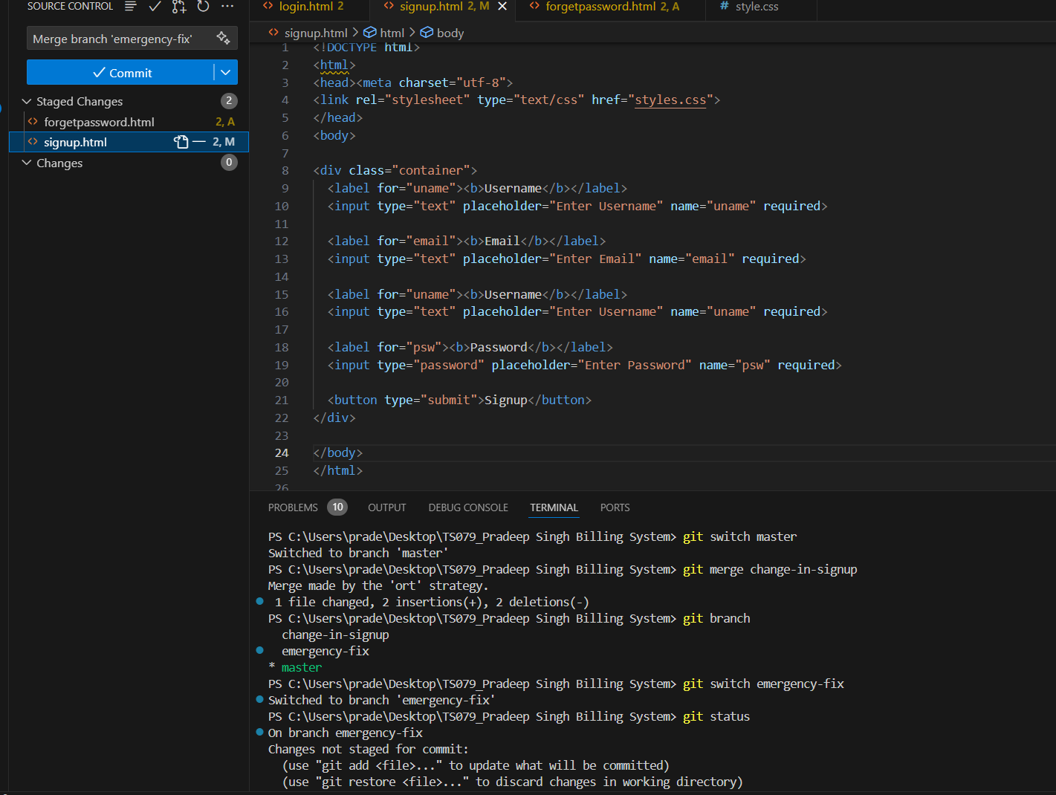



**Step 11:After merging push this to remote repo called Billing System created in Azure devops**



